**Installing Jenkins in Ubuntu machine with automated commands:**

**Step 1:**

Create a shell script-

vi Jenkins.sh and paste below command

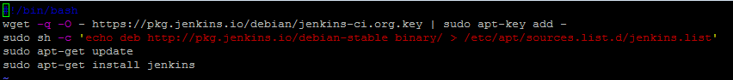

#!/bin/bash

wget -q -o - https://pkg.jenkins.io/debian/jenkins-ci.org.key | sudo apt-key add -

sudo sh -c 'echo deb http://pkg.jenkins.io/debian-stable binary/ > /etc/apt/sources.list.d/jenkins.list'

sudo apt-get update

sudo apt-get install jenkins

**Step 2:**

Save and quit-

Step 3: change the permissions to make it executable



Chmod u+x jenkins.sh

Step 4:

Run the executable file

./jenkins.sh

